
Sreenidhi Institute of Science and Technology
(An Autonomous Institution)
Regulations:
A14
Code No: 4F302 Date:13-Dec-16(FN)
B. TECH. II-Year I-Semester Examinations, Nov/Dec 2016 (Supplementary)
MATHEMATICAL FOUNDATIONS OF COMPUTER SCIENCE
(Common to CSE and IT)

Time: 3 Hours Max. Marks: 70

Note: No additional answer sheets will be provided.

Part - A
Max.Marks:20

Answer all QUESTIONS. EACH QUESTION CARRIES 2 MARKS.
- Define molecular and atomic statements. [2M]
- Write the negation of [2M]
- What is poset? Give an example. [2M]
- Explain concepts of homomorphism. [2M]
- What is null graph? Give an example. [2M]
- What is chromatic number? [2M]
- Write the general solution of the Fibonacci relation for [2M]
- Write the concept of sub-monoid. [2M]
- Write any two properties of binary relation. [2M]
- How many arrangements of the letters in MISSISSIPPI have no consecutive S’s? [2M]
Part – B
Max.Marks:50

ANSWER ANY FIVE QUESTIONS. EACH QUESTION CARRIES 10 MARKS.
Note:- All sub-sections of a question must be answered at one place only

- a)Show that is tautologically implied by . [5M]
b) Obtain the principal disjunctive normal form of .[5M]
2. a) Verify the validity of the following argument: " Tigers are dangerous animals.
There are Tigers. Therefore there are dangerous animals". [5M]

b) Write in brief about universe of Discourse with an example. [5M]

3. a) Draw the Hasse Diagram of where and the relation
“”, such that if divides. [5M]

b) Show that there are 15 partitions of a set of four elements. Draw the diagram of the
corresponding lattice. [5M]

4. a) Show that the set of natural numbers is a semi group under the operation
. Is it a monoid? Justify it. [5M]

b) Given that is group then find the inverse of . [5M]

5. a) Describe how to obtain all possible spanning trees for the following graph and list the total number of different spanning trees. [5M]
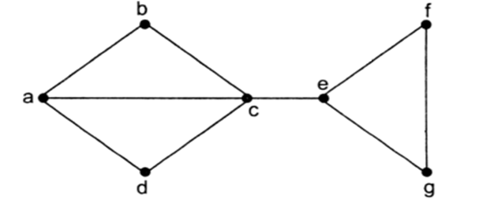
b) Suppose that we know the order and size of a non-directed graph G. Is it possible to
determine the degree of the vertices of G? Explain. [5M]

6. a) What is planar graph? Is planar? Justify your answer. [5M]

b) Find the chromatic numbers of
i) Tree, ii) C_{n} iii) K _{m,n} [5M]

7. a) Show that . [5M]

b) Let X={1,2,3,4}. If R={(1,3) ( 3,1), (2,4) ( 4,2) } and S= { (1,4) (4,1)} then find
and . [5M]

8. a) If and are two groups and is homomorphism, then prove that
the kernel of is a normal subgroup. [5M]

b) Find how many numbers are there between 1 and 65, which are divisible by any one
of 2,3 and 5. [5M]

-- 00 -- 00 --

